Camera-Back Physics: Revealing Coherence and Decoherence Through the Imprint Field Hypothesis

[Your Name]
[Affiliation]

Abstract
We introduce detector-plane dynamics and a camera-back visualization to reveal the geometry of imprint fields as they approach the measurement surface. Using simulations of the double-slit with and without which-path detection, we show how coherent imprint propagation produces interference corridors, how detector-induced phase randomization produces classical double-band intensity distributions, and how two-particle imprint correlations reproduce Bell–CHSH violations when coherence is preserved. This work positions the detector plane as the central interface between field propagation and observable outcomes and provides direct visual and quantitative links between coherence, decoherence, and entanglement.

1. Introduction
The double-slit experiment provides a classic demonstration of interference and measurement-induced collapse. We adopt the Imprint Field Hypothesis where a localized particle core coexists with a contextual imprint field that propagates through the environment. Measurement corresponds to damping/termination of this imprint at the detector plane. Here we introduce a camera-back visualization to make the pre-collapse field geometry explicit.

2. Detector-Plane Dynamics and Camera-Back Visualization
We place a virtual sensor at the detector plane and visualize the approaching imprint field by rendering from the detector back toward the slits. This perspective reveals how coherence or decoherence shapes the spatial geometry of the incoming field and therefore the measurable intensity distribution.
Figure 1: Figure 1 — Camera-back visualization (coherent). Representative snapshot showing overlapping imprint wavefronts approaching the detector.


Figure 2: Figure 2 — Detector-on transition (camera-back): imprint decoherence into two wings.
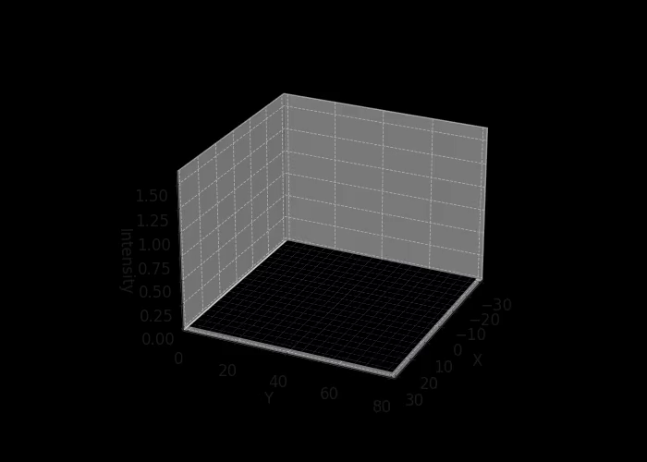

Figure 3: Figure 3 — Imaged detector (full): two Gaussian-like lobes under decoherence.
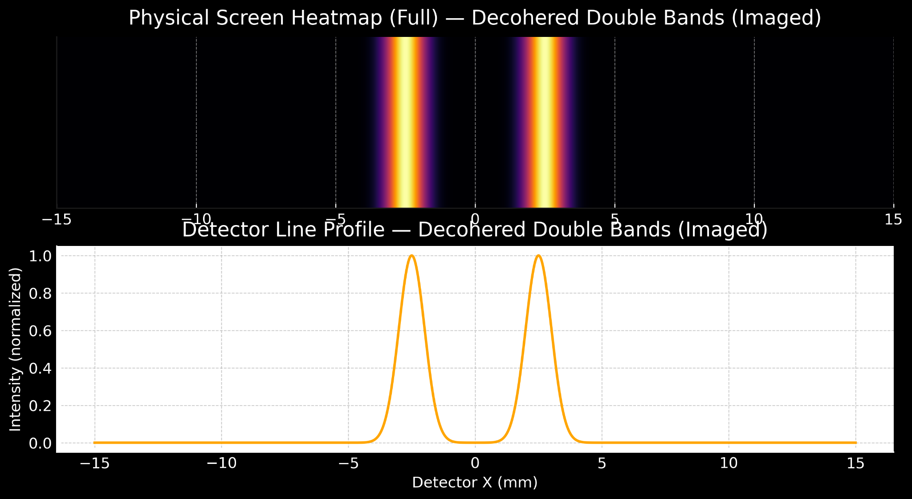

Figure 4: Figure 4 — Fraunhofer separated (full): parameter-tuned separated lobes.
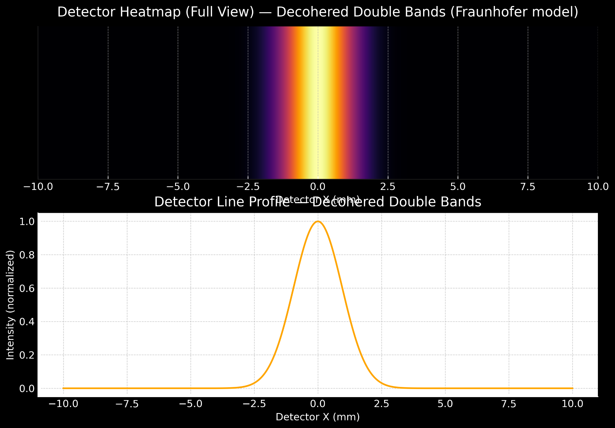

Figure 5: Figure 5 — CHSH correlators: coherent, partial decoherence, and fully decohered regimes.
[Image not available]

3. Imprint Field Model (Light Formalism)
We model the imprint field as a propagating Gaussian-envelope wavefront with phase, for a source at slit positions. A simple working form used in simulations is:
I(r,t) \propto \exp\left(-\frac{(r-R(t))^2}{2\sigma^2}\right) \exp\left(i(kr-\omega t)\right)
Decoherence is modeled by random phase injections to a slit component:
I_{\mathrm{dec}} = I \, e^{i\phi_{\mathrm{rand}}},\quad \phi_{\mathrm{rand}}\sim\mathrm{Uniform}(0,2\pi)

4. CHSH and Two-Particle Imprint Correlations
For two-particle imprint correlations we compute correlators E(α,β) and the CHSH quantity S using standard angle choices. The imprint-phase distribution controls the degree of violation.

5. Discussion
Detector-plane dynamics provide a clear mechanism linking propagation-level field geometry to observable interference and classical band outcomes. The camera-back view aids intuition and suggests direct experimental manipulations (local phase jitter, imaging optics) to control fringe visibility.

6. Conclusion
Placing the observer at the detector plane and visualizing the incoming imprint field reveals the mechanism by which coherence gives rise to interference and how decoherence produces classical outcomes. The imprint-field hypothesis thereby unifies interference, decoherence, and entanglement under a single field-based causal picture.

References
[References placeholder — populate with relevant citations]

